# Shielded Bonded Foam – PUR Insulation Test

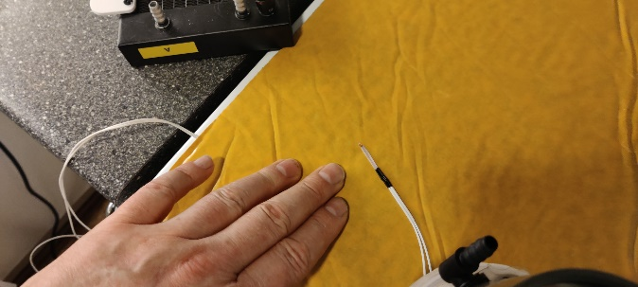

Figure : Heater On

Figure : 70C - Heater On

Figure : 80C - Heater On

Figure : 90C Heater On

Figure : 100C - Heater Off

Figure : 112C - Max Temp - Heater Off

Figure : 100C Heater Off

Figure : 90C - Heater Off

Figure : 80C - Heater Off

